**Title:**

Building a circuit using a demultiplexer

**Date:**

29/NOV/2018

**Aim:**

The aim of the experiment is to design, build and test a circuit that uses a 74138 3 to 8-line decoder/demultiplexer and minimal additional circuitry to implement the function:

F = x’ y z’ + x z

**Analysis:**

I expected to get a truth table as shown below.

|  |  |  |  |
| --- | --- | --- | --- |
| **Input** |  |  | **Output** |
| **A** | **B** | **C** | **out** |
| 0 | 0 | 0 | 1 |
| 0 | 0 | 1 | 0 |
| 0 | 1 | 0 | 0 |
| 0 | 1 | 1 | 0 |
| 1 | 0 | 0 | 0 |
| 1 | 0 | 1 | 0 |
| 1 | 1 | 0 | 0 |
| 1 | 1 | 1 | 1 |

**Karnaugh Map:**

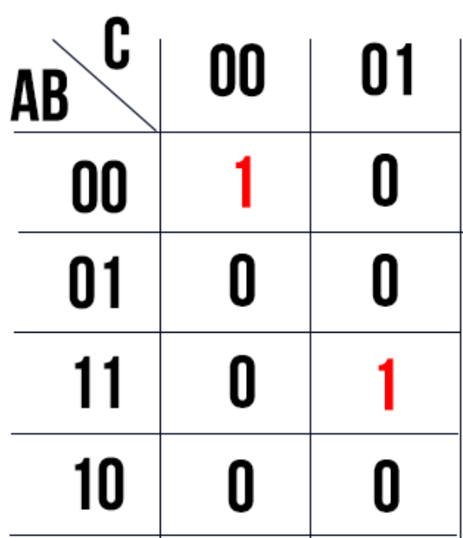

**Logic Diagram:**

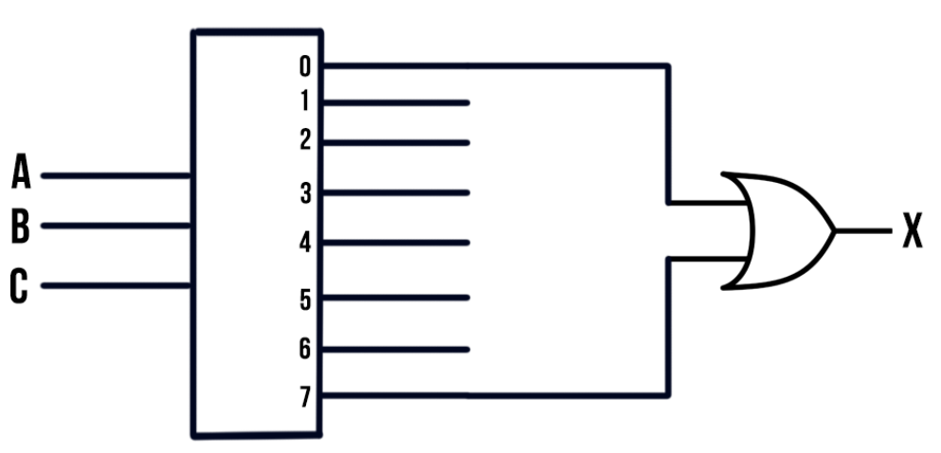

The logic behind the diagram is that if A, B and C are off, then the output would be on and if A, B and C are on, then the output would remain on. Otherwise, the output would be off.

**Results:**

|  |  |  |  |
| --- | --- | --- | --- |
| **Input** |  |  | **Output** |
| **A** | **B** | **C** | **out** |
| 0 | 0 | 0 | 1 |
| 0 | 0 | 1 | 0 |
| 0 | 1 | 0 | 0 |
| 0 | 1 | 1 | 0 |
| 1 | 0 | 0 | 0 |
| 1 | 0 | 1 | 0 |
| 1 | 1 | 0 | 0 |
| 1 | 1 | 1 | 1 |

**Conclusion:**

In conclusion, the truth table from our analysis of the circuit diagram matched that of our results. The Karnaugh map (above), matched the results I got.